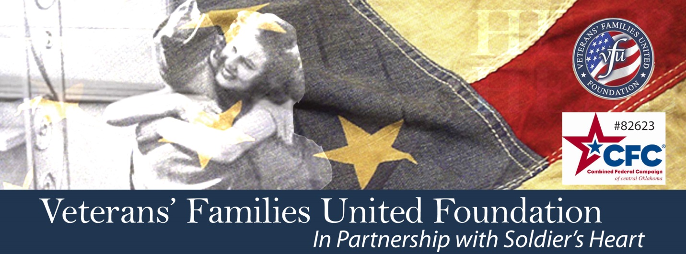
November 2013 Family Member Retreat
Information and Registration Form

Registering for the Retreat: Fill out the accompanying Application Form and send it to
clarkcounsel@cox.net. You will receive verification of the receipt of the application and information if space is still available. (405-474-3467 contact phone if needed)

Coming to the Retreat: Participants will need to make arrangements to arrive at the
Forest of Peace (www.ForestofPeace.org) between
5:00 pm and no later than 6:00 pm on Friday, Nov. 15, 2013.
141 Monastery Road, Sand Springs (see their website)

The Retreat Accommodations: The Forest of Peace offers sparse and rustic small cabins with
2 twin beds (you will be sharing a room) and a shower.

There are no phones or televisions (cell service available).
All the meals are served at a community table.
There is no smoking or alcohol permitted on the 40 acre refuge.

What to Bring: Comfortable and casual clothes appropriate for the climate.
Walking shoes. A favorite pillow. A journal. A book. An
item that symbolizes your journey as a family member. You!

What to Expect: Upon arrival, come to the main house to get your cabin assignment and agenda for the weekend. Dinner is at 6. Afterwards, we will all meet at the Community House and begin our agenda.

There will be a variety of group and individual activities created to address our “stories” and to connect us with ourselves and one another. We have made great efforts to create a place of safety and to balance the delicate stories and emotions we have experienced as family members of wounded warriors.

We ask that retreatants participant in all the offerings of the weekend and that privacy is honored.
Fall Retreat for Families of Veterans’
November 15-17, 2013 - Retreat Application

Your Name: Click here to enter text.
Address: Click here to enter text.

Phone: Click here to enter text.
Email: Click here to enter text.

Your Relationship to Veteran: Click here to enter text.

Do you have a support system for you: Yes ☐ No☐

About the Veteran

Branch of Service: Click here to enter text.
Conflict in which Veteran Served: Click here to enter text.
Nature of Injury: Click here to enter text.

Emergency Contact Information

Name: Click here to enter text.
Phone: Click here to enter text.
Email: Click here to enter text.

Payment for Retreat

☐ I am able to pay the $100.00 offering

☐ I need assistance to pay for the retreat

Terms of Retreat Attendance

☐ I have read the “Retreat Information” and this application sheet and agree to the information shared.

Save the information that you have completed on this document and return it to clarkcounsel@cox.net. Please call 405-535-1925 and leave a message if you have any questions. You will be advised within 2 weeks about the status of your application. Thank you for your interest and for YOUR service!
VFU and Soldier’s Heart offers this retreat to provide some options for healing and does not endorse nor recommend any specific technique. VFU and Soldier’s Heart does not guarantee results or outcomes.
www.VeteransFamiliesUnited.org

